**Stamford University of Bangladesh**



**Lab Project Report 03**

**Course Title** : Software Engineering Sessional

**Course Code** : CSI 332

**Project Name** : Stamford Blood Donor System

**Submitted To** : Ashfaq Ali Shafin

Lecturer

Dept. of Computer Science Engineering

Stamford University of Bangladesh

**Submitted By** : Joydeb Paul Anupam ID : CSE 063 07447

Faisal Chakladar ID : CSE 063 07461

Sajib Roy ID : CSE 063 07511 Dept. of Computer Science Engineering

Stamford University of Bangladesh

**Date of Submission : 28 September 2019**

**Introduction:**

This report has covered one essential parts of this project. These are: **Data Flow Diagram**. Data Flow Diagram is a graphical representation of System’s dataand how the process transform data. This is the most common way of documenting the process of current and required System.

**Data Flow Diagram (DFD):**

**Activity List:**

|  |  |  |  |
| --- | --- | --- | --- |
| **Admin** | **User** | **Gust User** | **Donor** |
| Add content | User can post | User can post | Tap |
| Delete content | When blood need | When blood need | Yes/ No |
| Update Content | Post can edit | Post can edit | Show date last donate blood |
|  | Post can delete | Post can delete |  |
|  | In location wise | In location wise |  |
|  | Can call by mobile | Can call by mobile |  |
|  |  |  |  |
|  |  |  |  |
|  |  |  |  |

**Main Process**: Stamford Blood Donation System

**Sub Process**: Micro-Credit, Education, Administration, Payroll

**Entity**: Admin, User, Stock, Donor

**Database**: Admin_Info, User_Info, Stock_Info Donor_Info, Content, Time_Working.

**DFD - Context Level:**

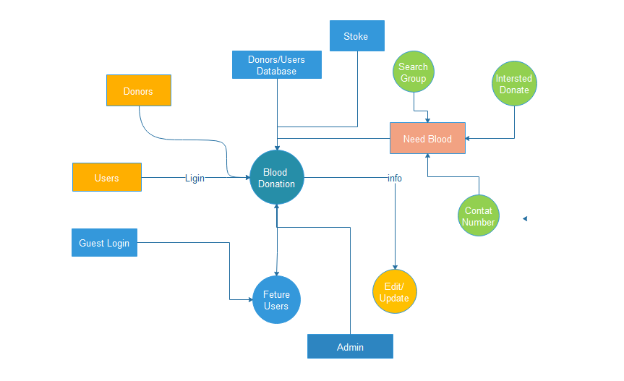

**DFD – Level 0:**

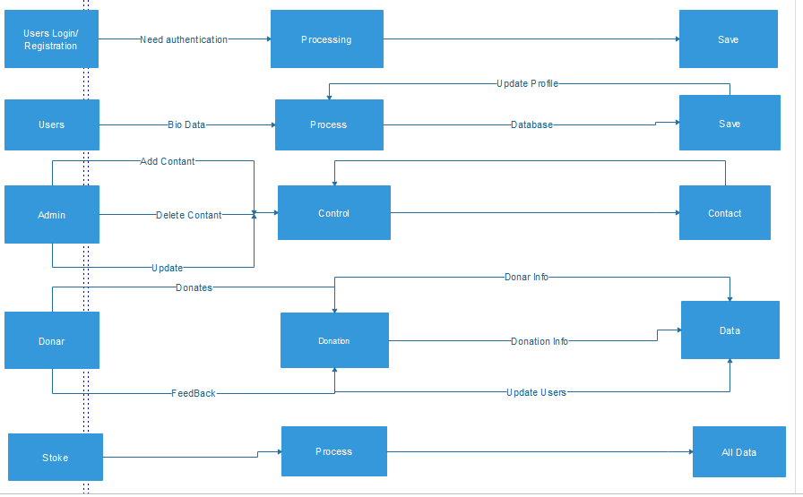

**DFD Level 1:**

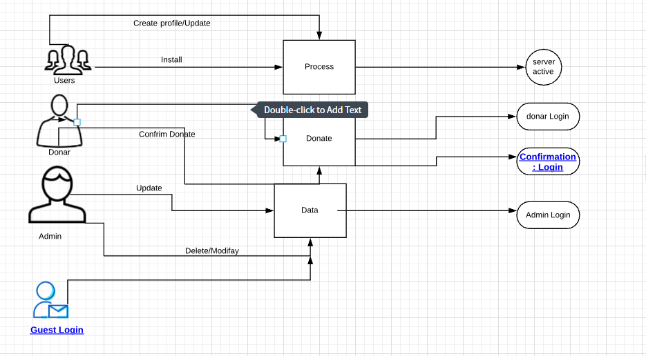

**Process Decomposition:**

|  |  |  |
| --- | --- | --- |
| **Context Level** | **Level 0** | **Level 1** |
|  |  |  |
|  | 1.0 Admin | Create  Modify  Admin login |
|  |  |  |
|  | 2.0 User | Install  Create profile update  Process Server active |
| **Stamford Blood** |  |  |
| **Donation System** | 3.0 Donor | Confirm donate  Donate  Donor Login |
|  |  |  |
|  | 4.0 Gust | Install  Process Server active |
|  |  |  |

**Conclusion:**

This concludes the Data Flow Diagram. This report deals with how data are being processed and when they are processed.